标题：Information Search Within a Web Page: Modeling the Full Sequence of Eye Movement Decisions, Subjective Value Updating, and First Clicks
作者及机构:
Joy Lu: Marketing, Carnegie Mellon University, Pittsburgh, Pennsylvania 15213
J. Wesley Hutchinson: Marketing, University of Pennsylvania, Philadelphia, Pennsylvania 19104
摘要: Online retail settings often present shoppers with large, complex choice sets where they need to quickly and dynamically weigh the benefits and costs of search within each web page. We build a model of information search within a web page using eye-tracking data collected during two incentive-compatible online shopping experiments, in which participants browsed the websites of two different clothing retailers (Experiments 1 and 2), as well as previously reported data from a laboratory experiment involving choices among snack food assortments (Experiment 3). Our model incorporates features that build upon recent advances in descriptive and normative models of information sampling and search in psychology and economics. First, our model captures how people decide where to look by treating eye fixations on clickable options as a series of “split-second” decisions that depend on estimates of option attractiveness and navigation effort. Second, our model assumes that the value of each option is learned via Bayesian updating. Third, the choice to end search on the web page depends on a dynamic decision threshold. Our model outperforms benchmarks that assume random search, instant learning, fixed thresholds, nonheterogeneous thresholds, and stochastic accumulator stopping rules. Explicitly modeling the sequence of eye fixation decisions results in accurate counterfactual simulations of the effects of hypothetical product orderings on search duration and quality as verified using experimental manipulation, and it can be applied flexibly to a wide range of web-page layouts. Systematic differences across experiments highlight the importance of accounting for product familiarity, choice-set size, and the role of category outside options.
AI标题: 眼球追踪重构消费决策模型：动态贝叶斯阈值优化电商搜索路径
AI精炼: 该研究聚焦消费者行为与电子商务交叉领域，探讨在线购物中用户如何通过视觉搜索在网页内完成决策。针对传统模型无法精准刻画动态眼球运动序列与实时价值更新的局限，作者创新性地整合心理学与经济学的双重视角，提出两阶段动态决策模型。第一阶段基于吸引力（产品偏好、价格）与视觉成本（距离、滚动）构建眼球定位概率；第二阶段引入贝叶斯学习机制更新价值评估，并设计动态下降的决策阈值模拟搜索终止逻辑。通过三组眼动追踪实验（服装电商与零食选择），模型成功量化了产品排序对搜索效率的影响，揭示出"劣品前置布局延长停留但降低选择质量"的悖论。相比随机搜索、固定阈值等基准模型，该方法首次实现从微观眼动序列到宏观点击行为的端到端仿真，为网页设计优化提供了可计算的行为预测工具。
关键词:
两阶段动态决策模型
贝叶斯学习机制
动态决策阈值
眼球追踪数据建模
AOI吸引力模型
视觉搜索成本量化
探索-开发启发式
点击流预测算法
学术要点: 学术要点 1：动态决策阈值（Dynamic Decision Threshold） 决策阈值随注视次数线性递减，反映长期探索-利用权衡机制，与固定阈值模型形成核心差异。|||
学术要点 2：贝叶斯价值更新（Bayesian Value Updating） 通过正态分布先验与观测值的贝叶斯递归，实现产品吸引力参数的渐进式学习，突破传统即时学习假设。|||
学术要点 3：AOI吸引力-努力权衡（AOI Attractiveness-Effort Tradeoff） 兴趣区域选择模型整合产品属性吸引力（价格/偏好）与眼球运动成本（滚动/距离/粘滞性）的多维效用函数。|||
学术要点 4：异质性阈值模型（Heterogeneous Threshold Model） 决策阈值参数（ρ,δ）在个体层面呈现异质性分布，解释不同用户的搜索持续性与终止模式差异。|||
学术要点 5：序列采样-顺序搜索融合（Sequential Sampling-Search Integration） 将心理学序列采样模型（注视决策）与经济学顺序搜索模型（最优停止规则）进行跨学科理论整合。
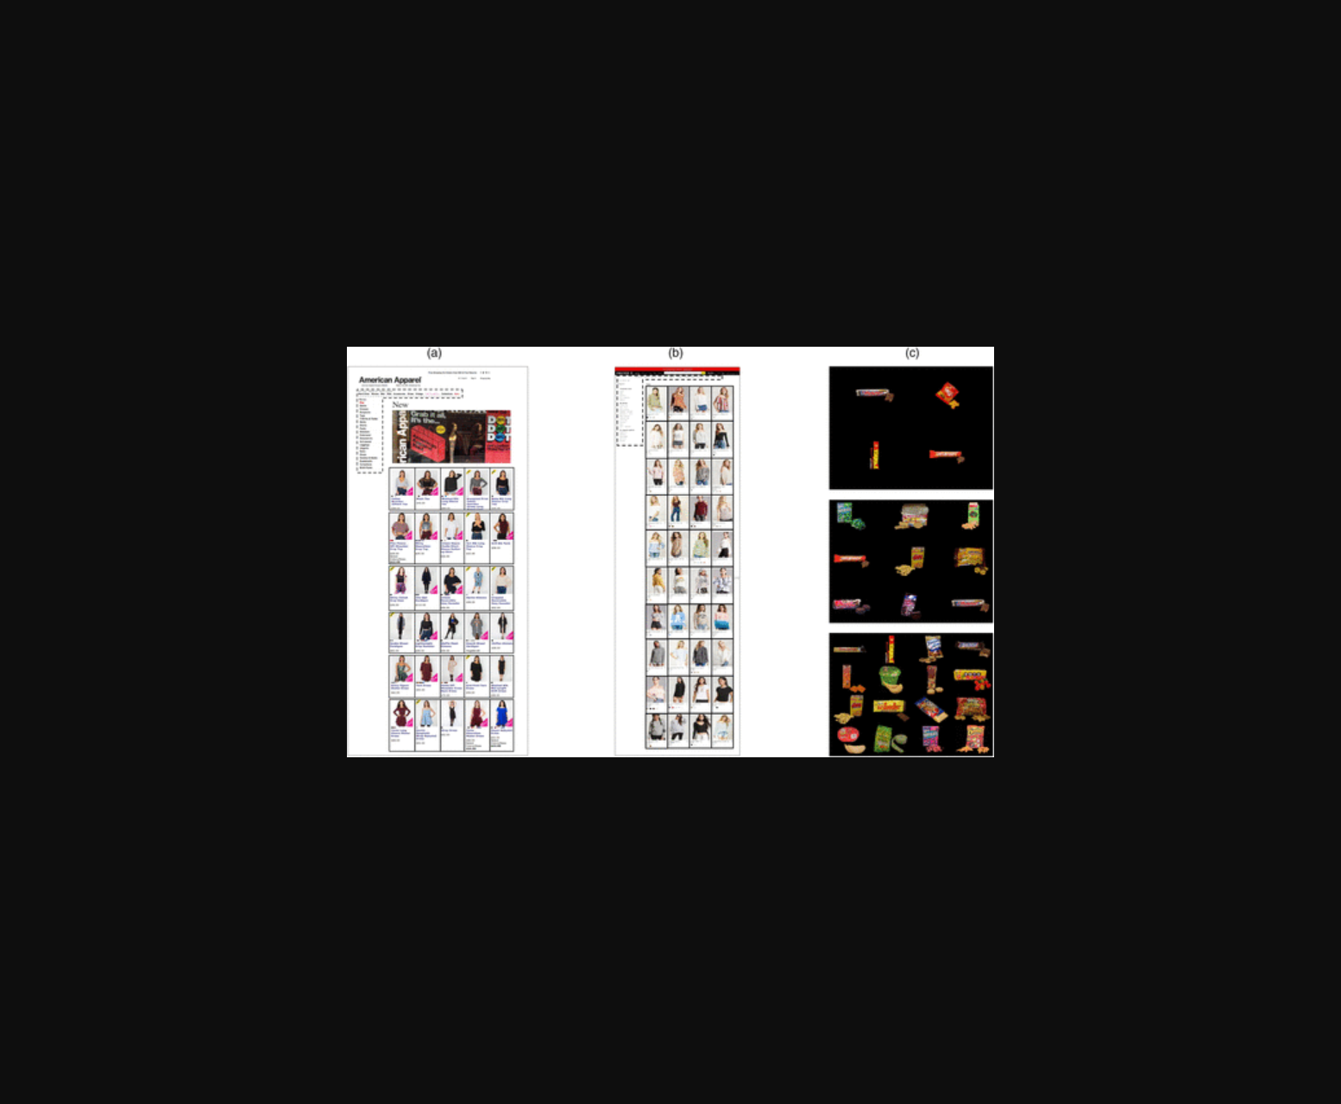
图片展示了在线购物实验中参与者浏览服装网页时的眼动轨迹热力图，通过注视点分布反映动态搜索决策过程。
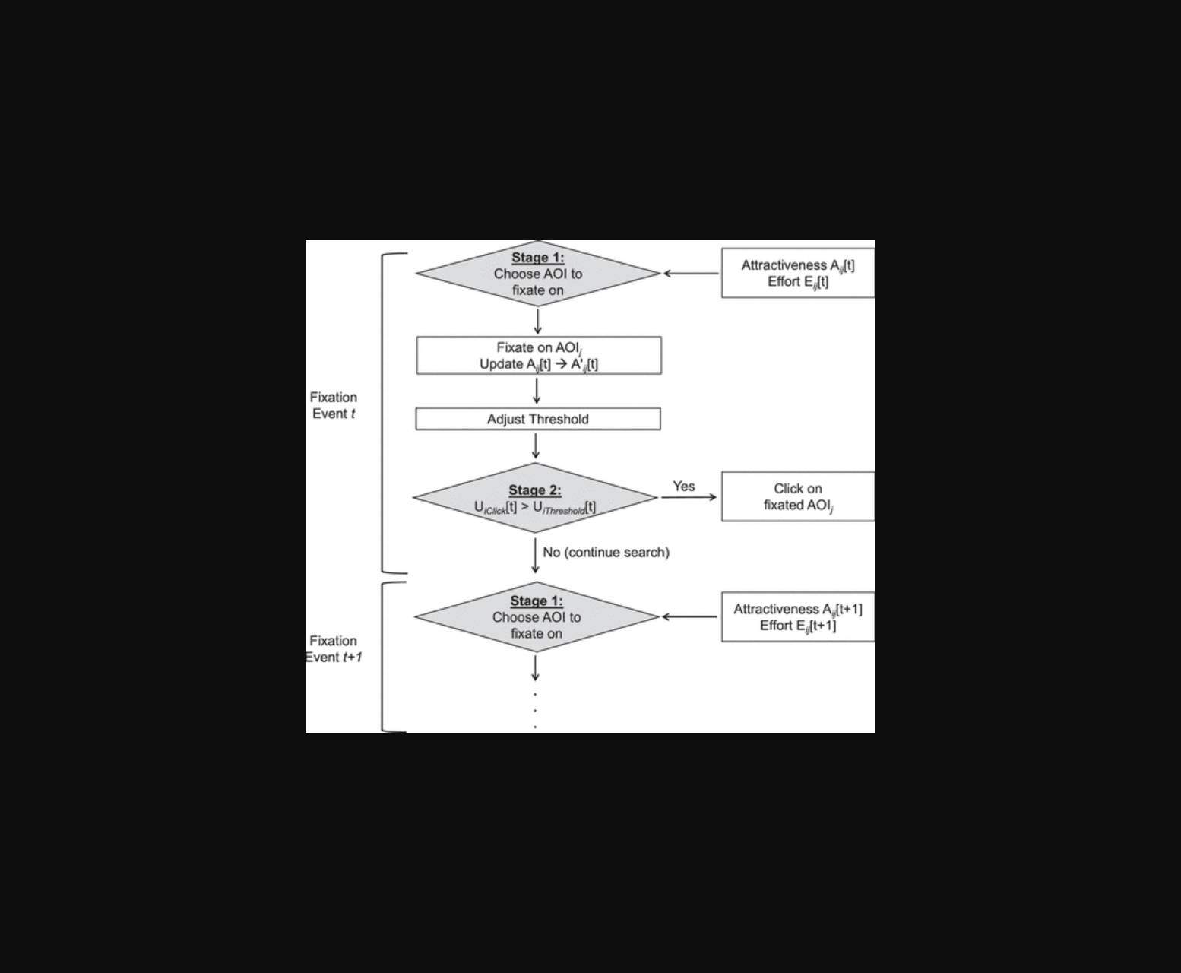
该图展示了在线购物实验中消费者眼动轨迹与动态决策阈值的模型示意图。
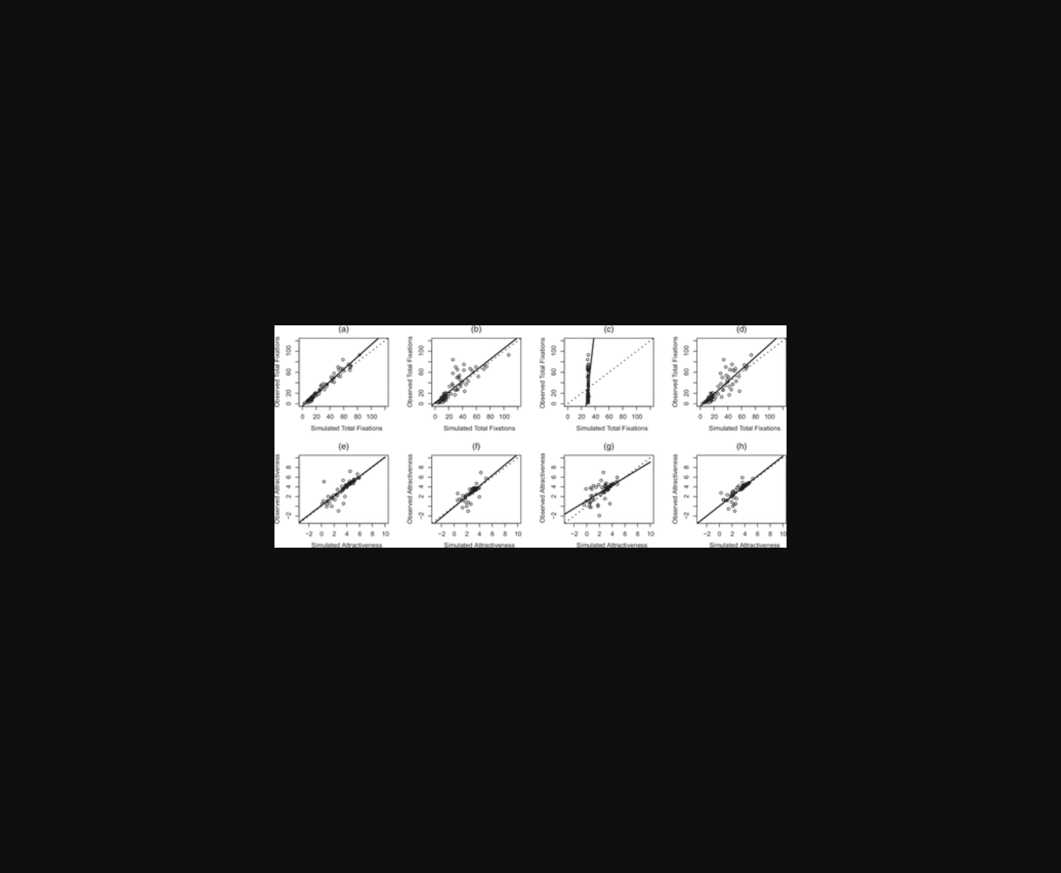
该图通过眼动轨迹数据呈现了在线购物者浏览网页时的动态搜索决策过程。
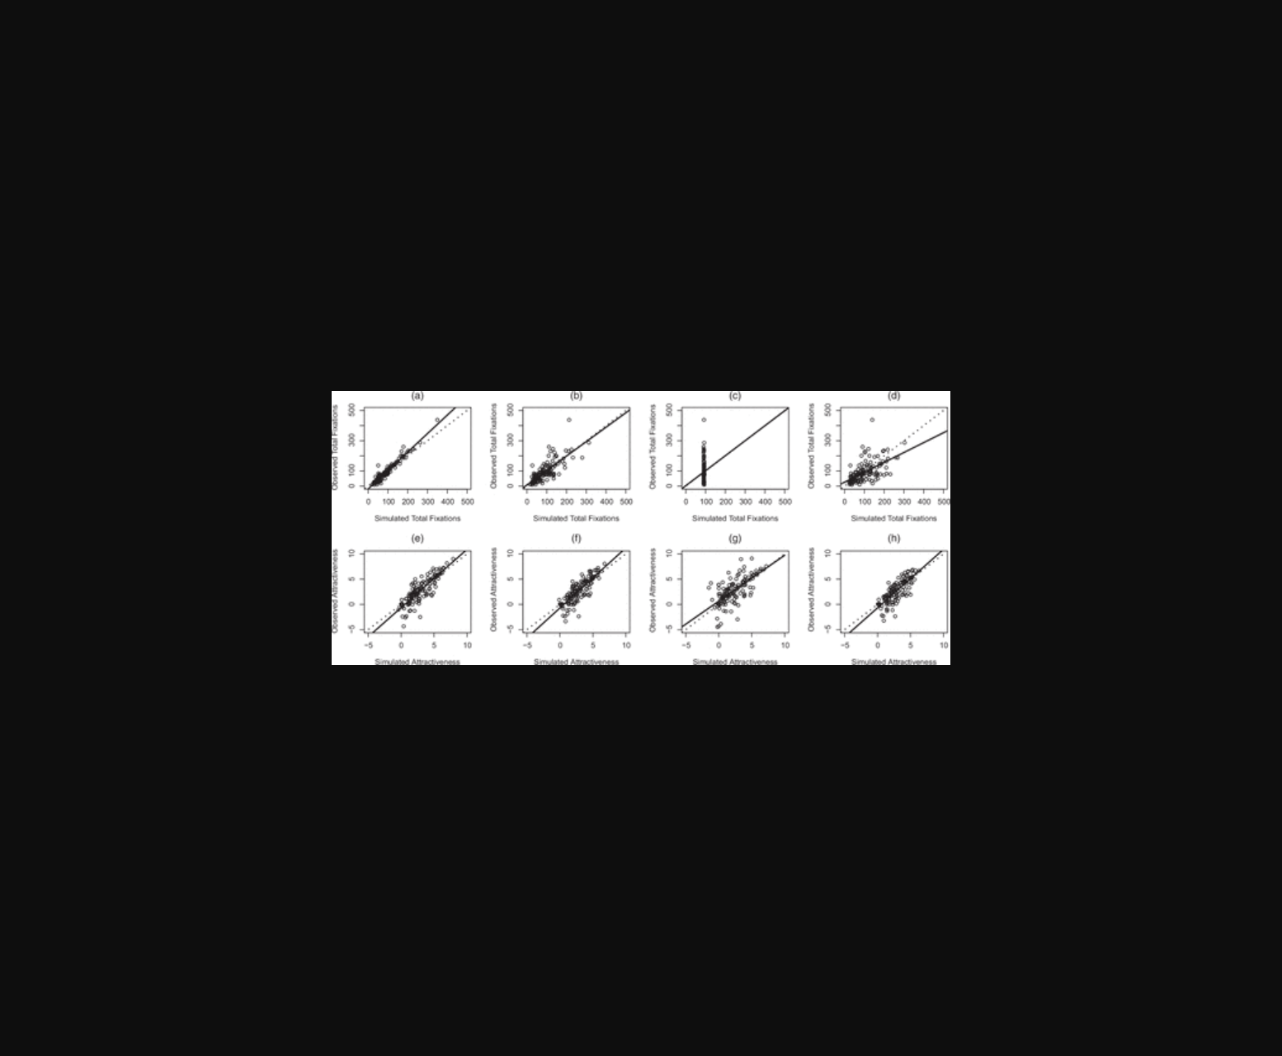
图E展示网页浏览中消费者眼动轨迹的决策模型及动态搜索阈值模拟。
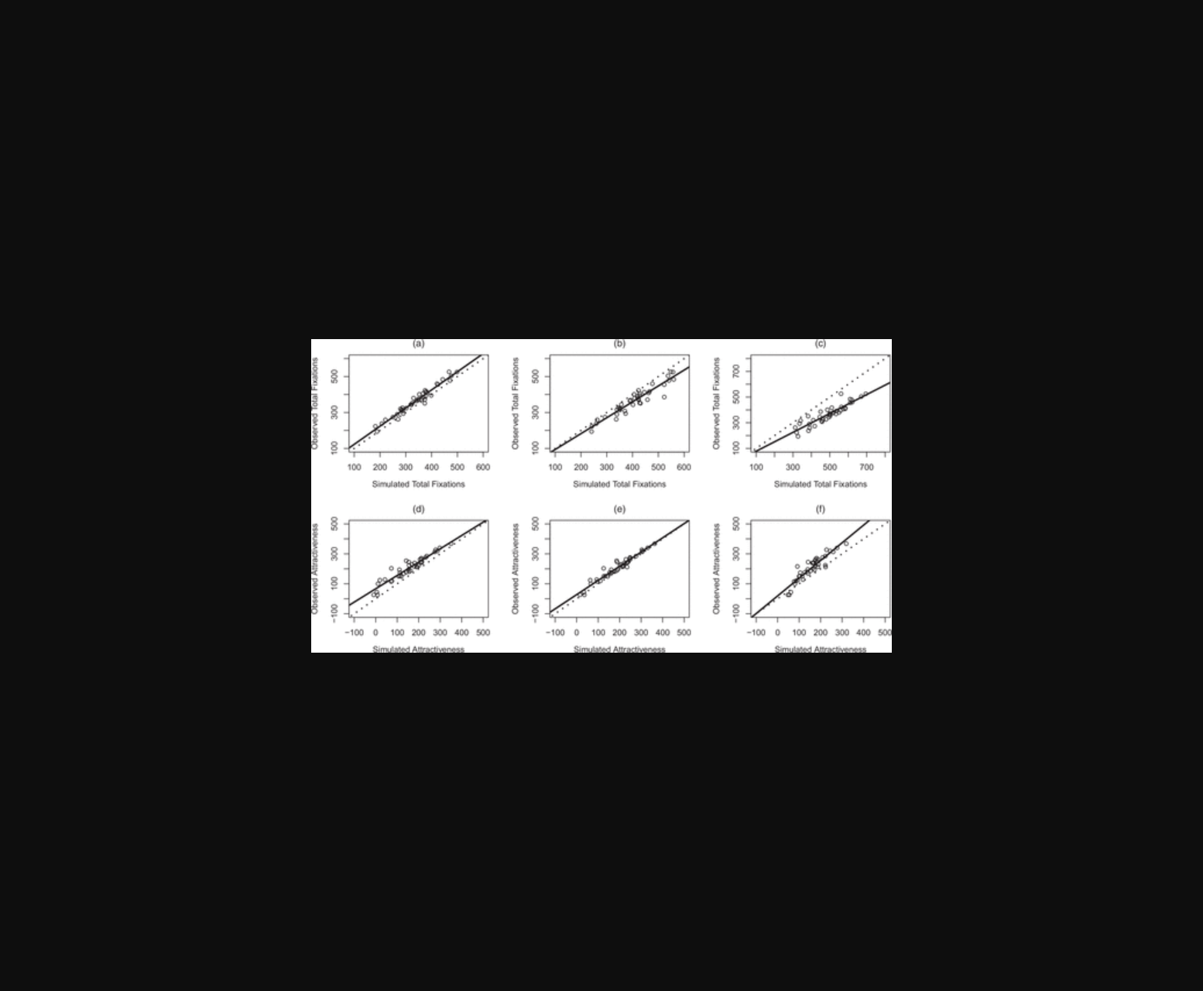
图示在线购物实验中的眼动追踪热点分布与动态决策阈值模型。
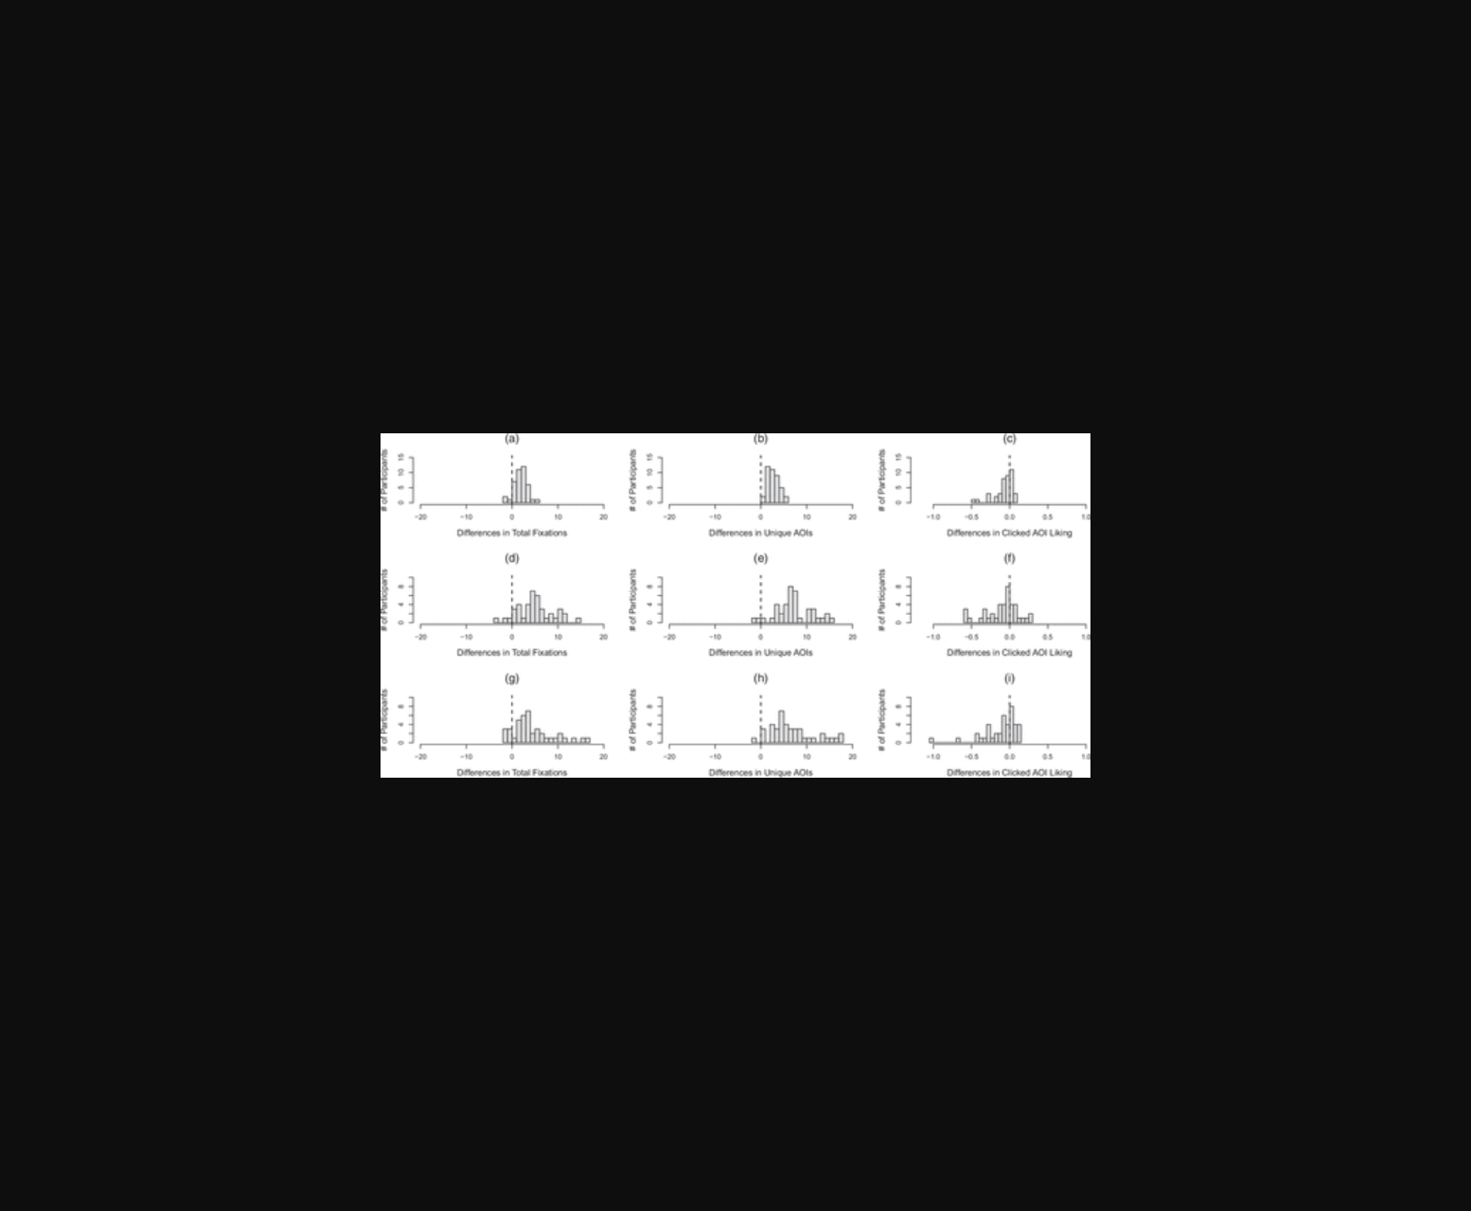
图示通过眼动追踪技术呈现消费者在服装网页的视觉搜索轨迹与决策阈值变化。
原文链接: https://doi.org/10.1287/mnsc.2022.02983

